Nepal College of Information Technology
Assessment
Fall 2012
Program : ELX Time : 3 hrs
Semester : Fall (V) FM : 100
Subject : Control Systems PM : 50

- Candidates are requested to give their answer as far as practicable in their own words.
- The figure in the margin indicates the full marks
- Attempt ALL question

1. a) What do you mean by automatic control system? List the major advantages of automatic control system. [7]

b) Calculate the sensitivity of the closed loop transfer function, M with respect to the forward path gain G. where G(s)= 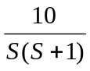 ; H(s)=5 [8]
2. a) Obtain the mechanical system for the electrical system shown in figure. [7]

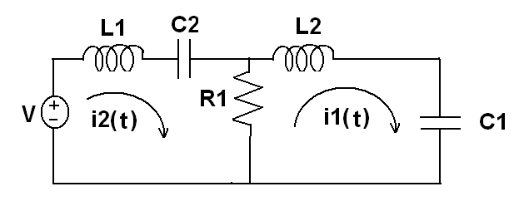
b) For the mechanical system evaluate X1(s)/F(s). Also obtain force-current analogy. [8]
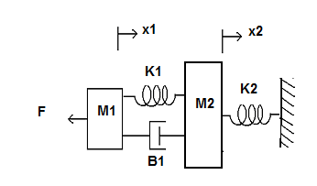
3. Determine the overall transfer function C(s)/R(s) for the system represented by the Block diagra shown below.

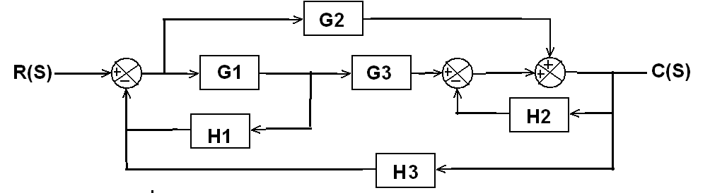

Also obtain the overall transfer function of the system using SFG technique. [15]
4. a) Using Routh Criteria determine the range of stability for the unity feedback control system shown below. [8]

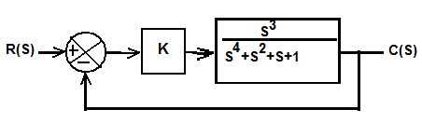

b) Differentiate between relative and absolute stability [7]

5. a) The open loop transfer function of a unity feedback control system is given by
G(s)= 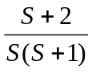
Determine the rise time, maximum overshoot and the system response for a unit step input. [8]

b) The open loop transfer function of a unity feedback control system is given by
G(s)= 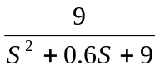 Find the static error constant and steady state error of the system when subjected to input r(t) = 1 + t + (t²/2) [7]
6. Sketch the root locus plot for the open loop transfer function
G(s)H(s)=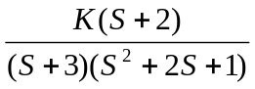 [15]

7. Write short notes on (Any two): [5*2=10]

a) Human control system
b) Effect of adding poles and zero to the transfer function
c) Peak time (tp) for a second order system

